Summer Transition Work
cnewton@st-albans.suffolk.ac.uk jhicks@st-albans.suffolk.sc.uk
Subject: Religious Studies
(Philosophy, Ethics & Theology)
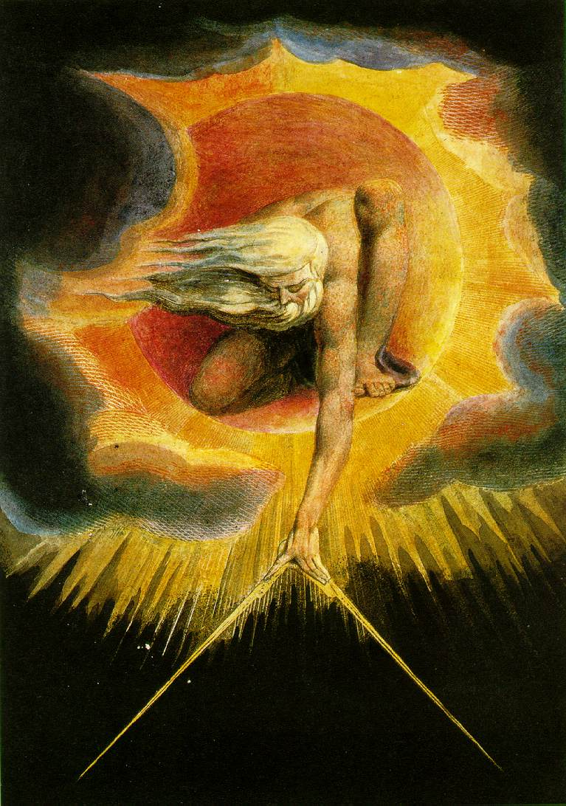

Welcome to Religious Studies

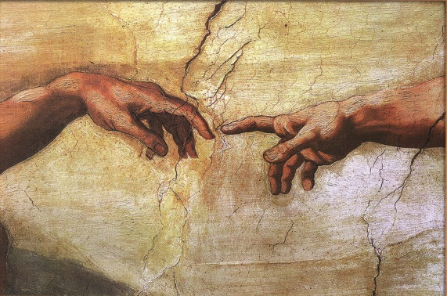
First of all, let’s explore what the subject actually is. A Level Religious Studies consists of 3 units across 2 years; Philosophy of Religion, Religion and Ethics and Development in Christian Thought.

You will tackle big Philosophical questions such as; ‘What makes an action right or wrong?’ ‘Is there life after death?’ What is God like?’, ‘Why is there evil?’ and even ‘Does God exist?’ You will think about Ethical issues such as Abortion, Euthanasia, Business, Sex and Conscience as well as others in detail. You will also think about Theological Christian ideas such as; ‘Are all religions true?’, ‘Is there one path to salvation?’ and ‘Is religion sexist?’

Philosophers and theologians have been asking these kinds of questions for thousands of years (even before Jesus!) and now it is your turn. You have decided to embark on an exciting journey that may lead you to question things and discover others you never even considered before.
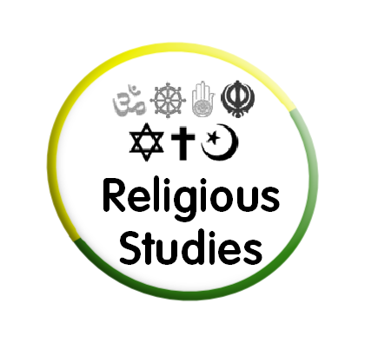
Subject Expectations
In this subject, you will be required to:
- Question your own views;
- Do extra reading and writing outside of class;
- Debate important questions and issues in philosophy, ethics and Theology;
- Develop writing skills via homework and directed study essays;
- Become an inquiring and curious person!
Useful Websites and Reading Material
Websites:

- The examination board is OCR: http://ocr.org.uk/qualifications/as-a-level-gce/as-a-level-gce-religious-studies-h173-h573-from-2016/
- Philosophical Investigations is helpful to get a sense of the subject: http://peped.org/
- Either or essays will give you an idea of how the course is assessed: https://eitheroressays.com/

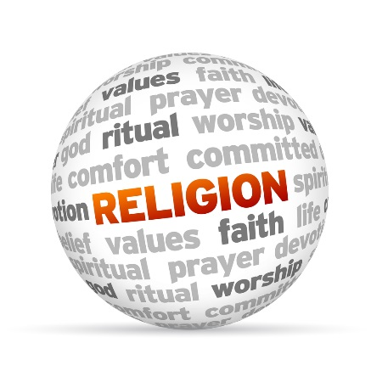
Interesting books for further reading:

- The Puzzle of God: by Peter Vardy
- Is there a God: by Richard Swinburne
- The Theory of Knowledge: by Peter Cole
- Issues of Life and Death: by Michael Wilcockson
- Man’s Search for Meaning: by Viktor Frankl
- Beyond Good and Evil: by Friedrich Nietzsche
- The God Delusion: by Richard Dawkins

Summer Transition Work

Carry out some research to find out about a few of the famous theologians, philosophers, and figures we will be studying. Put together a fact file about them;
What do they say about our behaviour/right and wrong?
How do they approach a belief in God?
Their background, philosophical ideas and reasonings.
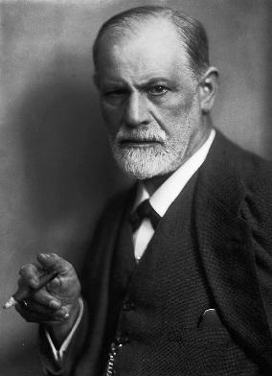
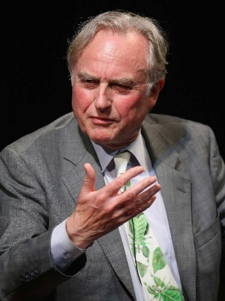
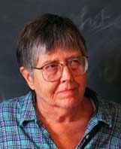
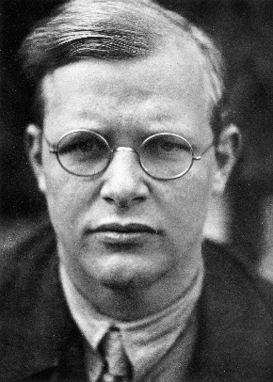
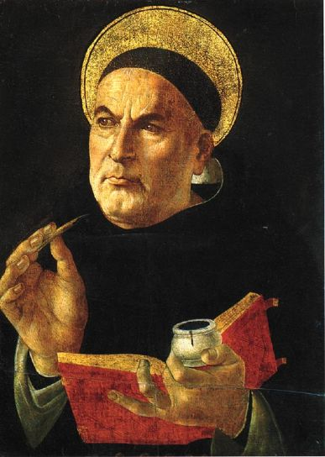
Sigmund Freud
(1856-1939)
Mary Daly (1928-2010)
Dietrich Bonhoeffer (1906-1945)
Richard Dawkins (1941-)
Thomas Aquinas
(1224-1274)

Progression Opportunities
The skills and knowledge acquired through studying Religious Studies provide a sound basis for students who wish to continue studying at University or another form of higher education. Some students go on to study Theology, Religious Studies or Philosophy as a degree in their own right, whereas others choose degrees in linking subjects such as; Sociology, Law, Politics, Psychology and History.
Due to the level of writing required to be successful in the course, Religious Studies can lead to careers in law, teaching, journalism, social work, research and a wide variety of industries that require good written and verbal communication skills.
Universities such as Oxford and Cambridge have said that they see A Level Religious Studies to be a valuable A Level as it allows students to be critical thinkers who can evaluate and reason at a high level.

