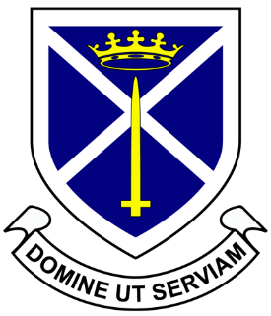
St Alban’s A Level Language
Y11 into Y12 Transition Work

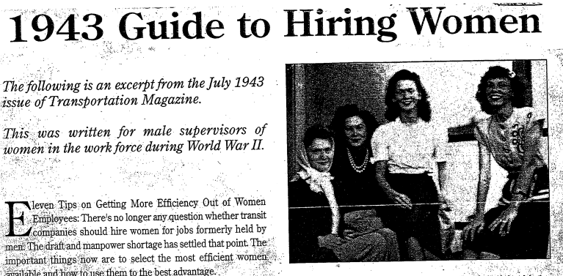

Task 1 – Language and Gender
Read the article from 1943 Guide to Hiring Women.
Write a short 150 word summary of how this article presents women historically.

Task 2 – Language and Accent/Dialect
1. Read the article on accentism and summarise the views and opinions expressed in a short paragraph.

2. Make a list of all of the British regional accents you can think of. Which are seen as the best and which are seen as the worst- why?

3. What is RP? Conduct some research on RP and explore how it links to the subject of accentism.


Things to have ready for next year:
- Highlighters
- Pens
- Backup pens
- An A4 notebook
- An open mind
- Your debating skills

