St Alban’s Catholic High School

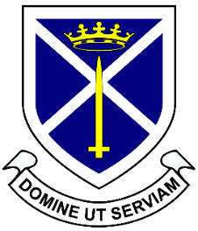

“Learning, Respecting, Caring”

Midday Assistant

Permanent Contract

Starting Salary £22,738 FTE (£2,538 actual)
5 hours per week / 38 weeks per year (term time only)
Monday - Friday

The Governors are seeking to appoint an enthusiastic and committed individuals to join our Midday Assistant team. The successful candidates will be required to supervise our students during their lunchtime break.

St Alban's Catholic High School strives to provide an excellent education for our students within a caring Christian community where all are respected, valued and supported to achieve their potential. Our mission statement is ‘Learning, Respecting and Caring’ and through this mission we aim to inspire, challenge, support and value every student to achieve their potential.

Please note: We have an open end date for applicants and will look to offer various dates for interview over the term.

Further details and an application form are available on the school’s website: https://www.st-albans.suffolk.sch.uk/Vacancies/

Application and disclosure forms should be submitted electronically to: recruitment@st-albans.suffolk.sch.uk

St Alban’s Catholic High School believes that safeguarding is a core responsibility shared by all members of staff. As such, all offers of employment will be subject to an Enhanced Disclosure and Barring check, evidence of Right to Work in the UK and satisfactory completion of all other pre-employment checks. Further details of the DBS code of practice, registration and suitability policy can be found through the following hyperlink.

https://www.gov.uk/government/publications/dbs-code-of-practice

