[](https://www.bing.com/images/search?view=detailV2&ccid=lnoZ3R2P&id=FB5674CE21CEFBFE40259D171F8A90BC5EB23D41&thid=OIP.lnoZ3R2Phj_YBZyyhVbicAHaFj&mediaurl=https%3a%2f%2fsmalltalkbigresults.files.wordpress.com%2f2012%2f10%2fadvice.jpg&exph=1536&expw=2048&q=advice&simid=608043827832030885&selectedIndex=0)**Advice & A Slice** 

Employer networking coming to St. Albans.

To be held in the 6th Form Library

**All Year groups welcome to attend.**

**You are invited to come along to listen and network with our guest speakers .**

The guest speaker will start at

**1.25pm – 2pm prompt**

**Wednesday 15th January**

**Games Programming**

We are very fortunate to have a representative from Game Anglia to talk to students about opportunities games programming can lead to

Come along and talk to an expert in games programming!

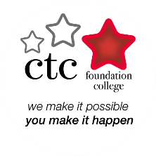

**Wednesday 22nd January**

**Performing Arts**

**Bridie Rowe (The CTC)**

CTC Foundation College is based in Needham Market, Suffolk and offers a one-year, full-time pre-vocational course in Musical Theatre for**ages 16 – 24 years**.

**Wednesday 22nd January** 

**BT Apprenticeships**

We receive tens of thousands of applications for BT apprenticeships every year. This presentation will help you make sure your application is as strong as it can be by finding out about the benefits of apprenticeships, come along for gain valuable tips and advice.

**Wednesday 29th January**

**Police**

Suffolk Constabulary offer a wide range of opportunities for exciting careers starting from a young age with the Police Cadet programme to a career rising through the ranks to Chief Constable. I look forward to answering your questions and encouraging the Police Officers of tomorrow.

**Wednesday 5th February**

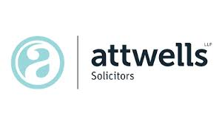**Law**

Attwells - Nick Attwell - Partner

Barker Gotelee - Rebecca Dixon - Associate

**Wednesday 12th February** 

**Darren Lewitt**

**Motivational speaker/mentor**

He has recently been featured on The One Show and Sky News as an ambassador for the Grand Mentor Scheme.

**Wednesday 11th March**

**Local Government**[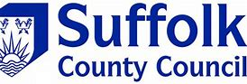](https://www.bing.com/images/search?view=detailV2&ccid=E%2bPOZ7Jl&id=3A43792F90E19363B0980DA607CD22CB17BECDC4&thid=OIP.E-POZ7Jlqhj_HQU7i0SzHQHaCU&mediaurl=http%3a%2f%2fwww.nef.org.uk%2fthemes%2fsite_themes%2fagile_records%2fimages%2fuploads%2fSuffolk_County_Council.png&exph=203&expw=649&q=suffolk+county+council&simid=608041633158991414&selectedIndex=1)

Find out about career opportunities in local government

**Wednesday 18th March**

**Fashion Design**

Former St Alban’s student, Sabrina de Carvalho runs her own bespoke bridalwear design company

**Wednesday 1st April** 

**NHS**

With more than 300 different careers on offer, there is a job for you, no matter

What your interests, skills or qualifications

**A slice of pizza will be available at each event.**

Staff are welcome to attend

**Health & Social Care**

Come and find out more about all areas in the health care industry

(nursing, medicine, psychology, physiotherapy)

.